INTERVIEW WITH A BODY ORGAN
THE STOMACH

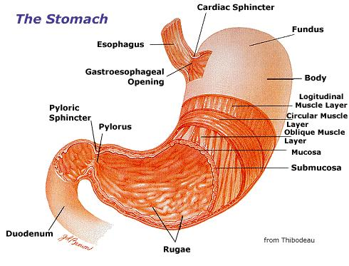

Elisa Soutullo García
3ºB ESO
1º Which organ have you chosen?
-I chose the stomach.

2ºWhere are you found in the body?
-The stomach is located in the abdomen below esophagus.

3º What do you look like?
STOMACH- I feel good. I'm comfortable in this body part.

4º Are you alone or do you come in pairs?
STOMACH- I haven´t partner. I am alone. But I'm happy, because my friend, the esophagus, ever keeps me company.

5º What job do you do?
STOMACH-My job is to store the food bolus and with the gastric juices makes “chime”. The bolus down the esophagus and into me by the cardiac and after being in my heart with gastric juice is ejected by the pylorus into the small intestine.

6º If you stopped working, could the body function without you or could it find a replacement/transplant and keep on going? If so , how?
STOMACH- If I stop working would be a disaster, because all other organs may not work well without me. If this were to happen you need an organ transplant.

7º What are some diseases that usually have?
STOMACH-Gastritis is the irritation of the gastric mucosa often causes inflammation.
Peptic ulcer: a wound caused by the destruction of the gastric mucosa that passes the muscularis mucosa.
Gastric cancer
Menetrier disease

8º What are your parts?
STOMACH-My parts are:
Cardiac sphincter
Gastro esophageal opening
Fundus
Body
Longitudinal muscle layer
Circular muscle layer
Oblique muscle layer
Mucosa
Submucosa
Rugaes
Pylorus
Pyloric sphincter

