Noela Barreiro Arufe, 3ºA ESO Nº1.
INTERVIEW WITH A BODY ORGAN.
Noela: Good morning, today I’m talking with a body organ, it’s a lung; the left lung.
Lung: Good morning, thank you for invite me.
Noela: Well… my first question is, where are you found in the body?
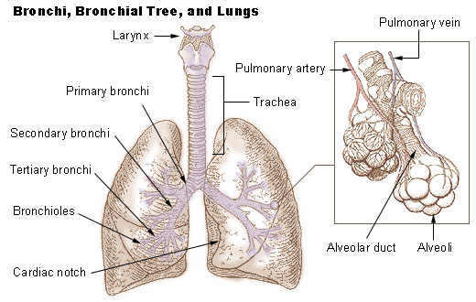
Lung: In mammals and the more complex life forms, I am located in the chest on either side of the heart. So, I’m the left lung and I’m smallest than the right lung, because I must lose site for the heart.
Noela: Oh! I know where you live, he he. And, what do you look like?
Lung: I have a spongy and soft texture and am honeycombed with epithelium, having a much larger surface area in total than the outer surface area of the lung itself.
Noela: Amazing, but… are you alone or do you come in pairs?
Lung: I said before, I work with other lung, with the right lung. In humans, the trachea divides into the two main bronchi that enter the roots of the lungs. The bronchi continue to divide within the lung, and after multiple divisions, give rise to bronchioles.
Noela: It is interesting know that. But I don’t know what job do you do?
Lung: My principal function is to transport oxygen from the atmosphere into the bloodstream, and to release carbon dioxide from the bloodstream into the atmosphere. This exchange of gases is accomplished in the mosaic of specialized cells that form millions of tiny, exceptionally thin-walled air sacs called alveoli.
Noela: M… You look like a very important organ. I have got a doubt, if you stopped working, could the body function without you or could it find a replacement/transplant and keep on going? If so, how?
Lung: Good question. And the answer is yes; if I stopped working you can find a replacement and keep on going. But the body can’t work without me. It’s amazing but a person can live with only one lung, but this person can live with some problems.
Noela: Yes, really it’s amazing. And the last question is, do you like be a lung?
Lung: Of course, I think that I’m the best organ in the body. And I don’t want be other organ. I and the right lung are the most important organs on the respiratory apparatus.

