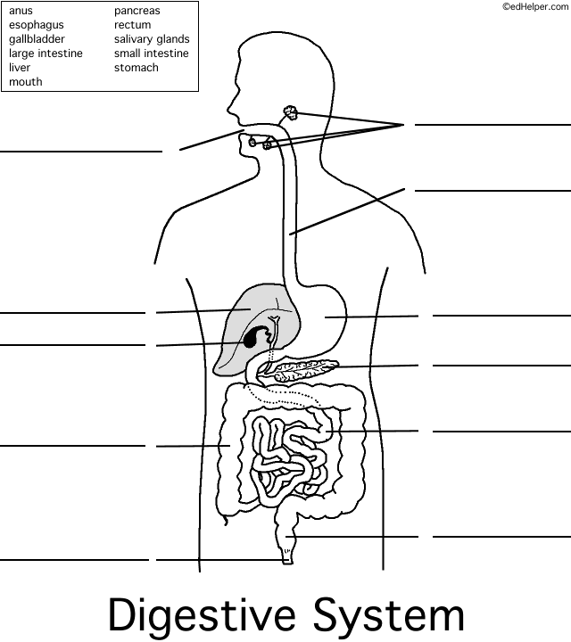
Name ________________________________

Label the parts of the digestive system using the vocabulary words in the box below. Be sure to spell each word correctly. Use colored pencils or crayons to color each part a different color.
11.
1.
2.
3.
4.
5.
6.
7.
8.
9.
10.

